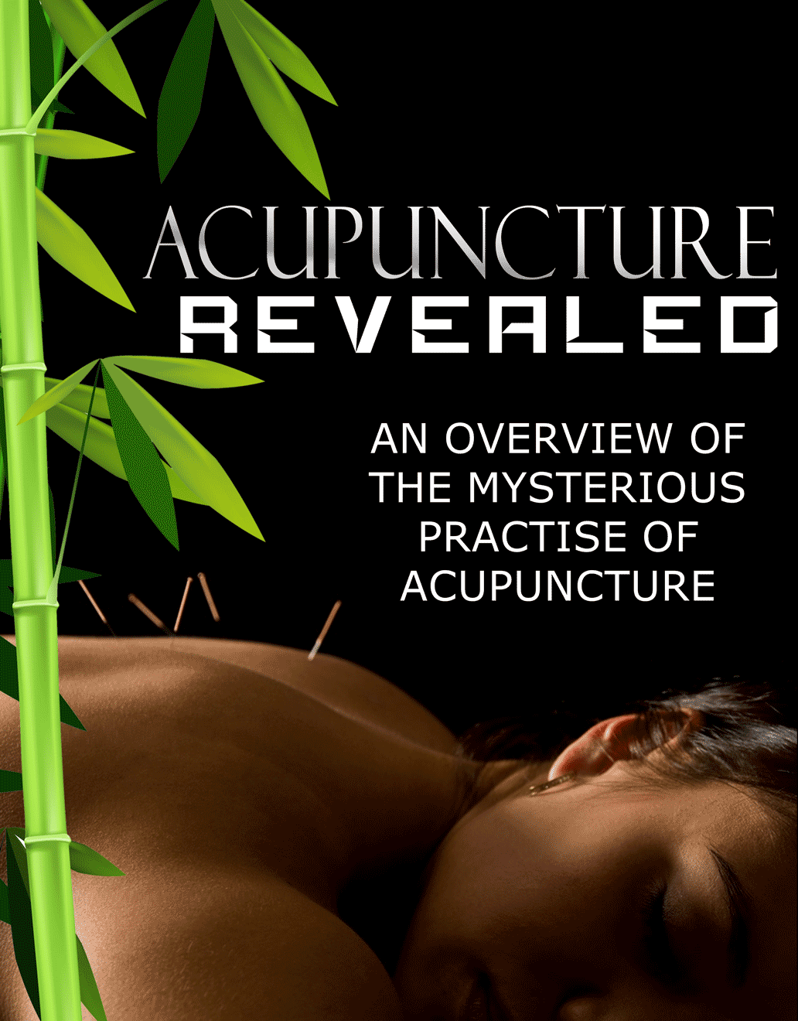

***Copyright © 2016***

All rights reserved. No part of this book may be reproduced, stored in a retrieval system, or transmitted in any form or by any means, electronic, mechanical, photocopying, recording, scanning, or otherwise, without the prior written permission of the publisher.

**Disclaimer**

All the material contained in this book is provided for educational and informational purposes only. No responsibility can be taken for any results or outcomes resulting from the use of this material.

While every attempt has been made to provide information that is both accurate and effective, the author does not assume any responsibility for the accuracy or use/misuse of this information.

You are encouraged to print this book for easy reading.

Use this information at your own risk.

Contents

Introduction – What Is Acupuncture? 4

How It Works 5

The Principles of Acupuncture 6

Conditions That Can Be Treated With Acupuncture 8

Headaches 9

Seasonal Allergies 10

Mood Swing or Imbalances 10

Acid Reflux and Heartburn 10

Heart Problems 11

Sleep Disorders 11

Other Conditions and Disorders 12

Here are the health conditions determined by the WHO: 12

Acupuncture Techniques 13

Basic Needle Insertion 14

Acupuncture Techniques 15

Acupressure 16

Moxabustion and Cupping 16

Conclusion 17

Procedure for Needle Puncture 18

Conditions for Puncture Application 19

Expected Puncture Session Result 20

# Introduction – What Is Acupuncture?

Firstly welcome to our overview of the practice of Acupuncture and thank you for joining me as we embark on a quick journey of discovery into this sometimes mysterious art. Let’s get started…

First and foremost, Acupuncture is a well-known alternative to mainstream medicine that originated from China. It is a branch of traditional Chinese medicine that dates back thousands of years, and is a widely accepted alternative form of medicine in the Western healthcare industry.

Today, it is widely used to treat different specific ailments such as chronic back ache and headaches, osteoarthritis, postoperative pain and vomiting, allergies, cancer-related conditions, stroke, and even infertility. It is a common substitute for patients that are looking for less aggressive types of treatment, but is not recommended to be used as the primary treatment in any kind of illness. Most places that practice acupuncture are found in the US, UK, and Asia, and are mostly done by private practitioners.

## How It Works

The word acupuncture comes from the Latin words acus and punctura, the former meaning needle, and the latter meaning to puncture. The procedure is literally the act of puncturing the skin with the use of fine needles with the aim of stimulating the body’s acupuncture points.

The needles may vary in size depending on the area it will be placed, and patients are asked to lie down as the needles are carefully positioned allowing it to penetrate the skin. The penetration, however, will not be deep enough to permanently damage the skin. The procedure may last for a couple of minutes to a few hours depending on the severity of your health concern. Although it may seem painful and scary at a glance, most practitioners guarantee that there will only be minimal pain much similar to a buzzing or stinging sensation, and patients who have undergone this treatment will be able to attest to the relaxing sensation it provides.

## The Principles of Acupuncture

The traditional form of acupuncture is firmly based on the principles of traditional Chinese medicine.

According to their beliefs, our bodies are filled with Qi, a life force that circulates through our body through the main organs. This same energy is then distributed to the entirety of our bodies, including the tissues, bones, nerves, and veins through channels known as meridians. These meridians can be likened to railways that easily transport Qi energy from one major organ to the other. The proper flow of Qi in our system creates a balanced environment in our bodies thus keeping us healthy. In line with this, traditional Chinese medicine believes that all diseases are caused by a certain form of imbalance whether caused by our environment or changes in our body.

In the modern age, the existences of both Qi and meridians have still not been proven by science. This has caused acupuncturists to take a different approach in explaining the process of acupuncture in relation to the treatment of pain.

A more acceptable explanation in the scientific field about how acupuncture works is the body’s release of endorphins and adenosine whenever a needle penetrates the skin. The said releases of these chemicals have been found to relieve pain and make patients feel better. The use of acupuncture can temporarily alleviate pain without having to take medication or undergo surgery. There is, however, no medical or scientific proof in its efficacy in eliminating major health conditions.

Add what you are comfortable with at your own pace. For some, that's a lot of changes right away. For others, it's one at a time. Only you truly know the answer to which way is best for you.

Well that’s a basic introduction to the world of Acupuncture, over the next few sections we will be looking at conditions that can be treated with Acupuncture as well as different techniques. Are you ready? Let’s go…

# Conditions That Can Be Treated With Acupuncture

Acupuncture, as well as other forms of traditional Chinese medicine provides a holistic approach in combating sickness and ailments. Their methods pay close detail to the whole body, the major organs, the energy called Qi that allows it to function properly, and the connections that distribute this energy to the entirety of the body. The process of acupuncture is deeply based on the importance of balance and harmony inside the body.

The process of acupuncture directly affects the 12 major organs of the body as described in Chinese medicine. It improves overall health and correct imbalances that result to sickness.

There are a wide variety of conditions that can be treated with acupuncture starting from the simplest to the most complicated. Listed below are just some ailments that can be treated with this unconventional mode of medicine.

## Headaches

Acupuncture has been proven to provide relief for headaches especially migraines. According to Prevention.com, 20 sessions of electro acupuncture within a span of at least a month, can reduce the number of migraines that could be experienced monthly.

## Seasonal Allergies

If antihistamines no longer prove to be effective, those who suffer seasonal allergies may opt to undergo acupuncture. A minimum of 12 acupuncture sessions may help to relieve the problem, allowing you to lessen the intake of medication.

## Mood Swing or Imbalances

Acupuncture does not only focus on the physical aspects of healing. It may also positively affect a patient’s mood, aiding in the treatment of depression within a span of three months. It has done wonders in improving a person’s overall emotional health, by stimulating the proper channels to produce the right amount of endorphins in the body.

## Acid Reflux and Heartburn

The treatment may also help in aiding digestion and regulating our body’s acid secretion. Constant visits to your acupuncturist in a course of a month, may help you find relief from acid reflux and heartburn. Acupuncture is a soothing alternative compared to taking medication.

## Heart Problems

Aside from exercise and healthy eating habits, regular acupuncture sessions have been proven to help alleviate stress, lower cholesterol and regulate blood pressure.

## Sleep Disorders

Stimulation of the acupoints help the body release chemicals that can aid the body‘s relaxation process. It also allows the body to increase the production of neurotransmitters that help in ward off insomnia and other sleep problems.

## Other Conditions and Disorders

The World Health Organization (WHO) has also released a list of conditions that may be treated with acupuncture. WHO tested the efficacy of this procedure using controlled clinical trials, however, patients are still advised to not rely on acupuncture as a primary form of medicine, but only as supportive treatment or temporary relief.

## Here are the health conditions determined by the WHO:

Muscular spasms and joint pain, sciatica, sprain, dental pain, nausea, vomiting, postoperative pain, stroke, hypertension, depression, as well as birthing complications, menstrual and fertility problems for women.

# Acupuncture Techniques

As we have learnt, Acupuncture is a simple yet delicate process that involves pre-sterilized fine needles, inserted into the skin to stimulate the body’s primary acupuncture points.

Although the idea of needles may seem daunting, the procedure is definitely painless. The needles inserted are usually slightly thicker than human hair, and may vary in thickness and size depending on which area it will be placed. The most common type of needle used has a length of 1.5 inches.

## Basic Needle Insertion

There are various techniques that may be applied when performing acupuncture. Acupuncturists are well-trained in the insertion and removal of the needles. Needling techniques may vary depending on where the needle will be placed on the body. In traditional acupuncture practices, needles are inserted with both hands placing it at an angle of 15 degrees or more. The skin surface may also be stretched to guide the entrance of the needle into the skin, using the right amount of speed and force.

For easier insertion, a guide tube may be used. Acupuncturists place the needle in the tube to position it exactly where it should penetrate the skin. After which, the practitioner taps the tube so that the needle smoothly slides onto the skin without any pain. Once the needle is inserted, patients are asked to look out for any feelings of heaviness, tingling, or electrical sensation in the point of insertion.

This is actually a good thing and is called “de qi” or “the arrival of qi” in acupuncture. This needling sensation may vary from patient to patient, but extreme and intense pain is a rare occurrence. Whatever sensation a patient may experience will also depend heavily on the health condition and the location of the acupoint. Some acupoints may exhibit a bit of pain when stimulated by the needle.

## Acupuncture Techniques

Needle insertion is the fundamental skill used in acupuncture, but there are also a variety of techniques that make use of other materials and elements. This may depend on the ailment to be treated and the comfort level of the patient. Below are just a few other forms of acupuncture.

## Acupressure

Acupressure is a technique that does not employ the use of needles. Acupoints are stimulated using the hands and fingers, similar to a massage. This technique may be used to alleviate muscle pain and tightness, while stimulating the overall flow of Qi in the body. This treatment is best for children and those with a low tolerance for pain.

## Moxabustion and Cupping

These techniques are also very popular and are oftentimes provided as services in massage parlors and spas. This technique uses heat to stimulate the acupuncture points. Moxabustion uses heated needles while cupping uses small glass cups to increase the flow of Qi in a certain are of the body. These are best in relieving muscle pain and spams, and eliminating body waste.

# Conclusion

Well we have reached the end of our overview on Acupuncture. In this final part we will be summarizing the main points we have covered so far and hopefully put to ease any questions or doubts you may have.

Using needles to adjust bodily functions to optimum levels is the principle behind acupuncture. Both ancient Chinese and modern Western practitioners have used this technique to relieve many sufferers of chronic disease.

Needling is a relatively safe, beneficial treatment strategy that can be used to reduce pain, improve healing, and increase general well-being.

## Procedure for Needle Puncture

There are two broad categories of acupuncture practice today, traditional Chinese medicine (TCM) and medical acupuncture. Both have their merits, so the choice is individual. The decision for most people hinges upon which philosophy appeals more to them and which technique holds the least apprehension.

In TCM, practitioners adhere to the concept of Qi, or energy flow, and the meridians in which they travel. They use longer needles and insert them deeper in order to reach the acupuncture points. Modern science has found little evidence to prove the existence of these energy channels, but this is the technique that has been used effectively for thousands of years.

In medical acupuncture, the practitioners are graduates of western medical schools. Their application of needles is not based on the traditional acupuncture points, but on anatomic data. These acupuncturists use shorter needles and the insertions are shallower. They also tend to use fewer needles and leave them inserted for shorter periods of time. Adherents to TCM feel this is a watered-down version of the real thing. Nevertheless, many patients have felt relief of symptoms through this method.

## Conditions for Puncture Application

There is a broad and extensive list of ailments which can be treated with acupuncture. The conditions run the gamut from asthma to constipation, anxiety to weight loss. Most TCM practitioners believe that any health condition results from an imbalance in Qi flow, therefore amenable to needle therapy. Western acupuncturists tend to have a more limited list of indications, the most common of which is undoubtedly control of pain.

Control of pain is the most well researched of all of the indications for acupuncture. There is a definite beneficial effect for a majority of patients using this method. Migraines, premenstrual syndrome, arthritis, carpal tunnel syndrome, and neuralgias are but a few examples. The theory behind its effectiveness is also medically accepted and well researched, called the gate-control theory of pain. It states that the needles can stimulate nerves so that they block the impulses from pain triggers.

## Expected Puncture Session Result

It is important to emphasize that acupuncture is used only on top of existing medical therapy. At no time should a patient discontinue medication or ignore medical instructions in favor of needle puncture. After undergoing a needle puncture regimen, the primary care physician can make an evaluation with regards to decreasing dependence on other therapies.

A course of acupuncture therapy will last anywhere from a few weeks to a few months. This depends upon the complexity of the particular medical condition. Results also vary, so it is important to have a frank discussion with the acupuncturist regarding expected results and their time frame. In general, the patient will begin to feel beneficial effects after three or four session. Certain specific conditions will actually get a little worse before improving so keeping informed is key.

In modern medicine, the use of traditional techniques with proven results has become a widely accepted practice. Acupuncture has proven its worth time and again. Modern practice guidelines make it effective, reproducible, and safe. It is a gift of healing from ancient sages that has the potential to bring relief to millions of people.

***“Thank God for Acupuncture, it’s been around for 2000 years. It’s not going anyplace and people use it all of the time for a variety of cures and to avoid illnesses”***

***Tim Daly***